**Online Retail Management System**

**TASK 1.1 : Research and list at least five benefits of cloud computing over a traditional on-premises infrastructure.**

**1. High availability:**

Online retail management system is always accessible and reliable for the customers and the retailers, even in the case of failures or outages. For example, a retail company can ensure uninterrupted service for its online store, even during high traffic or regional outages, by hosting it on Azure's globally distributed infrastructure.

**2. Scalability:**

Azure allows retailers to seamlessly scale their infrastructure up or down based on demand. For instance, during peak shopping seasons, a retail company can quickly scale up its resources to handle increased web traffic and transactions, and then scale them back down during normal periods.

**3. Elasticity:**

Cloud computing can provide the online retail management system with the ability to scale automatically and dynamically based on the number and behaviour of the customers. For example, an online retail management system can use elastic load balancing, which is a feature that distributes the incoming requests across multiple servers and instances and routes the requests to the best available server based on performance and availability.

**5. Fault Tolerance:**

For example, a retail company can design its Retail Management System automatically failover to redundant systems in different data centers to ensure uninterrupted service.

**6. CapEx and OpEx**

For instance, retailers can avoid upfront hardware costs and pay only for the services they use, leading to cost savings.

**TASK 1.2 : Describe the CapEx and OpEx models of financing IT infrastructure , providing examples of when each model might be preferred.**

Capital expenditures (CapEx) are major purchases a company makes designed to be used over a longer period of time while on the other hand, while Operating expenses (OpEx) are the day-to-day expenses a company bears to keep its business operations.  
Considering the IT infrastructure of an ecommerce application, it makes more sense to follow the OpEx approach since the server usage is unpredictable. It might be low at times and at times, especially during sales, we might face a surge in demand, when the server use might turn out to be more. Therefore, using cloud would give us the flexibility to pay as per our use only.  
Also, in some cases, due to government rules and laws, we might need to store customer’s sensitive, personal information on a private server. In this case, we would be required to make an investment in servers upfront.

**TASK 2.1 : Create a brief report differentiating between public, private, and hybrid clouds. Include a diagram that represents each cloud model.**

**1. Public Cloud:**

* Resources are shared among multiple customers.
* Data of multiple organizations is stored in the public cloud.
* It is operated by Third-party service provider.
* It has more scalability and flexibility.
* less expensive.
* 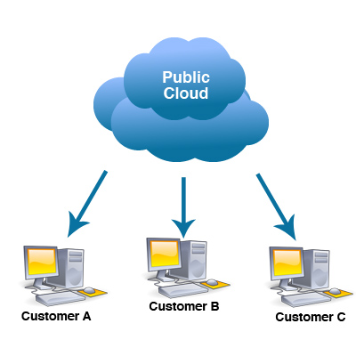It is available in the general public (over the internet).

**2. Private Cloud:**

* Resources are shared with a single organization.
* Data of a single organization is stored in a clouds the public cloud.
* It is operated by specific organization.
* It has predictability and consistency.
* More expensive.
* It is restricted to a specific organization.

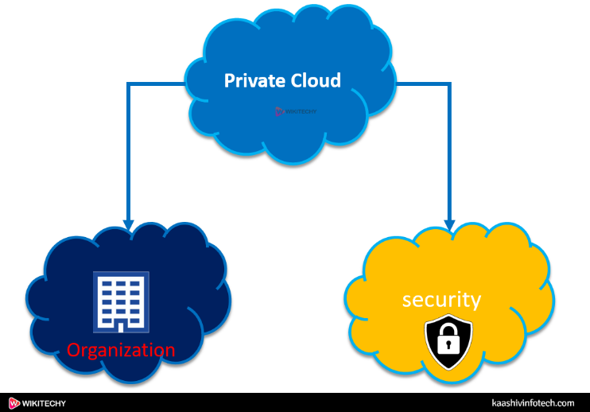

**3. Hybrid Cloud:**

* It is a  combination of public and private clouds. based on the requirement.
* Data is stored in the public cloud, and provide security in the public cloud.
* It can be a combination of both.
* It has scalability and flexibility by allowing organizations to use a combination of public and private cloud services.
* 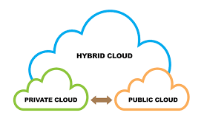It can be more expensive, but it can also be less expensive , depending on the specific needs and requirements of the organization.

**TASK 2.2 : For each cloud model, list one real-world application or scenario where that model would be the most appropriate choice.**

**1. Public Cloud:**

**Real-World Application:** A startup company developing a new mobile app chooses to host their app on a public cloud platform. The company has limited resources and wants to minimize upfront costs. They also anticipate a variable and potentially high volume of users, making the scalability of public cloud resources ideal for their needs.

**2. Private Cloud:**

**Real-World Application:** A financial services firm with strict regulatory requirements decides to build a private cloud to host its financial data and applications. The firm needs to ensure data privacy, security, and compliance with regulations such as GDPR and HIPAA. A private cloud allows the firm to have full control over its infrastructure and data, meeting its security and compliance needs.

**3. Hybrid Cloud:**

**Real-World Application:** A retail company uses a hybrid cloud model to manage its e-commerce platform. The company uses the public cloud for hosting its website and handling peak shopping seasons when traffic is high. It uses a private cloud for sensitive data such as customer financial information, ensuring security and compliance with industry regulations. The hybrid cloud model allows the company to scale resources up or down based on demand while maintaining control over sensitive data.